**Query string:-Query string is use for client side state management and state management is used to retain the value.**

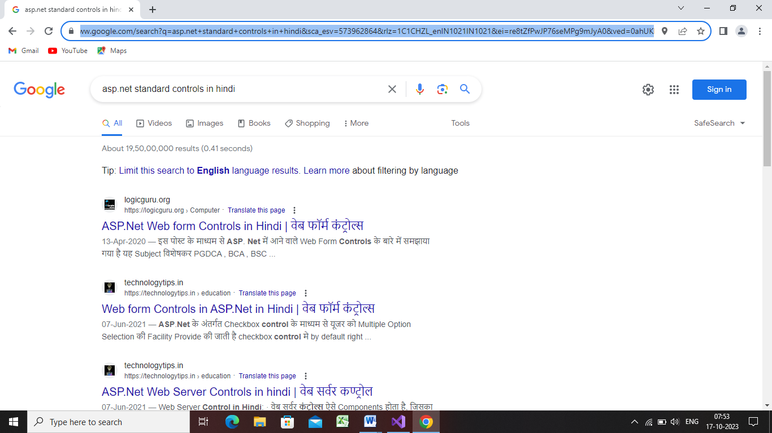

**Step 1:deign ur web page as shown below**

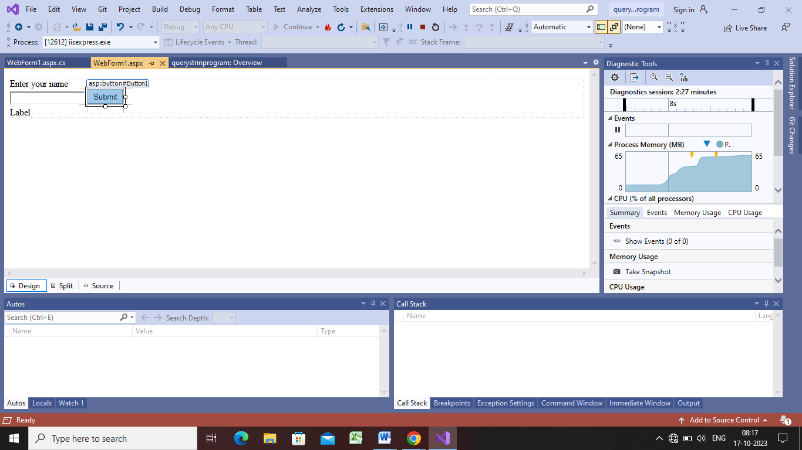

**Step2:**

protected void Button1_Click(object sender, EventArgs e)

{

Label2.Text = "welcome" + TextBox1.Text;

}

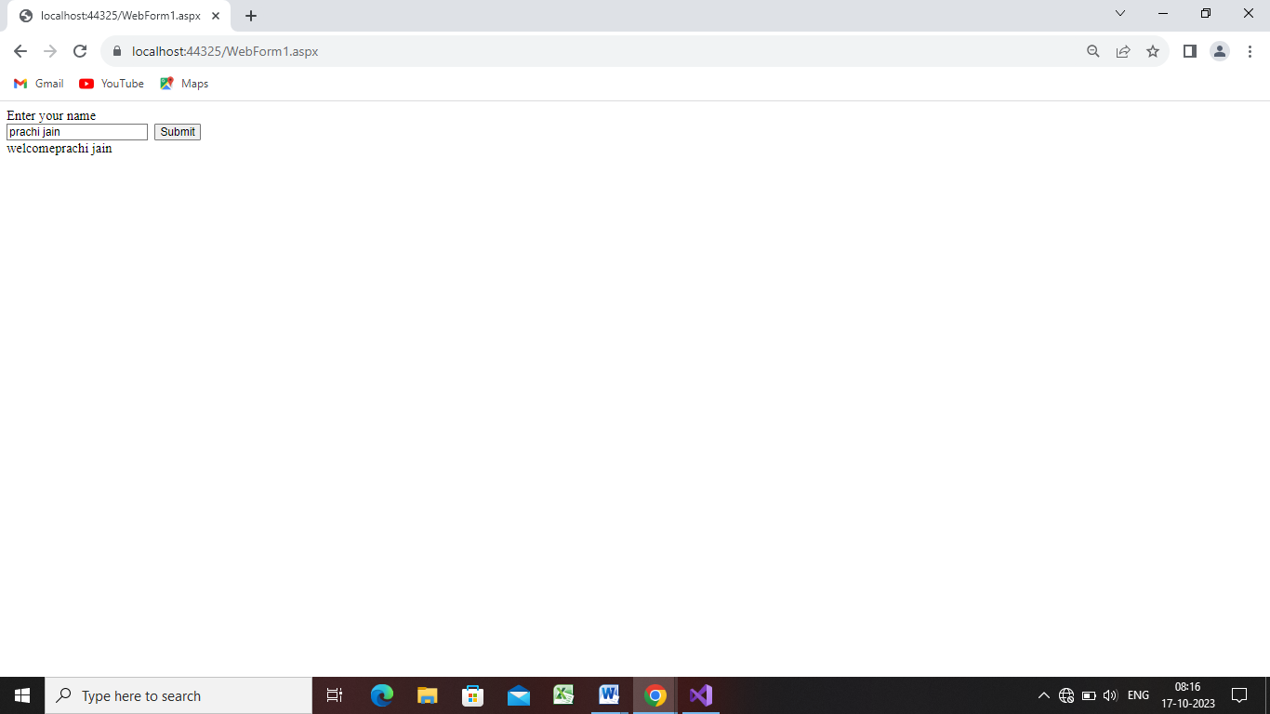

**Step 3:now delete the label2 and add new form webform2.aspx and change the coding of submit button**

**Webform1:-**

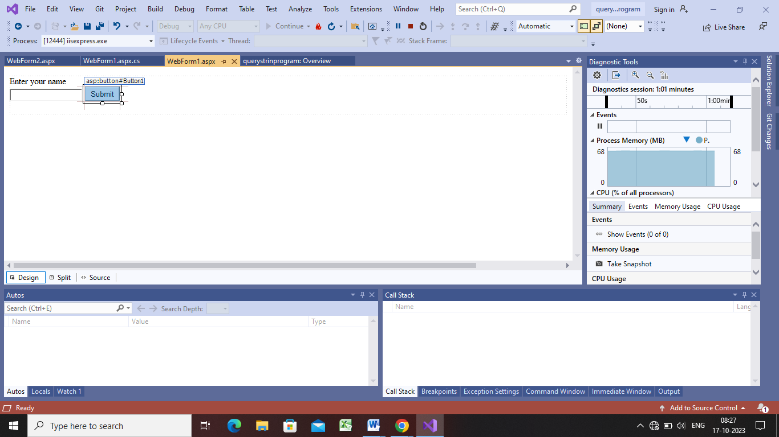

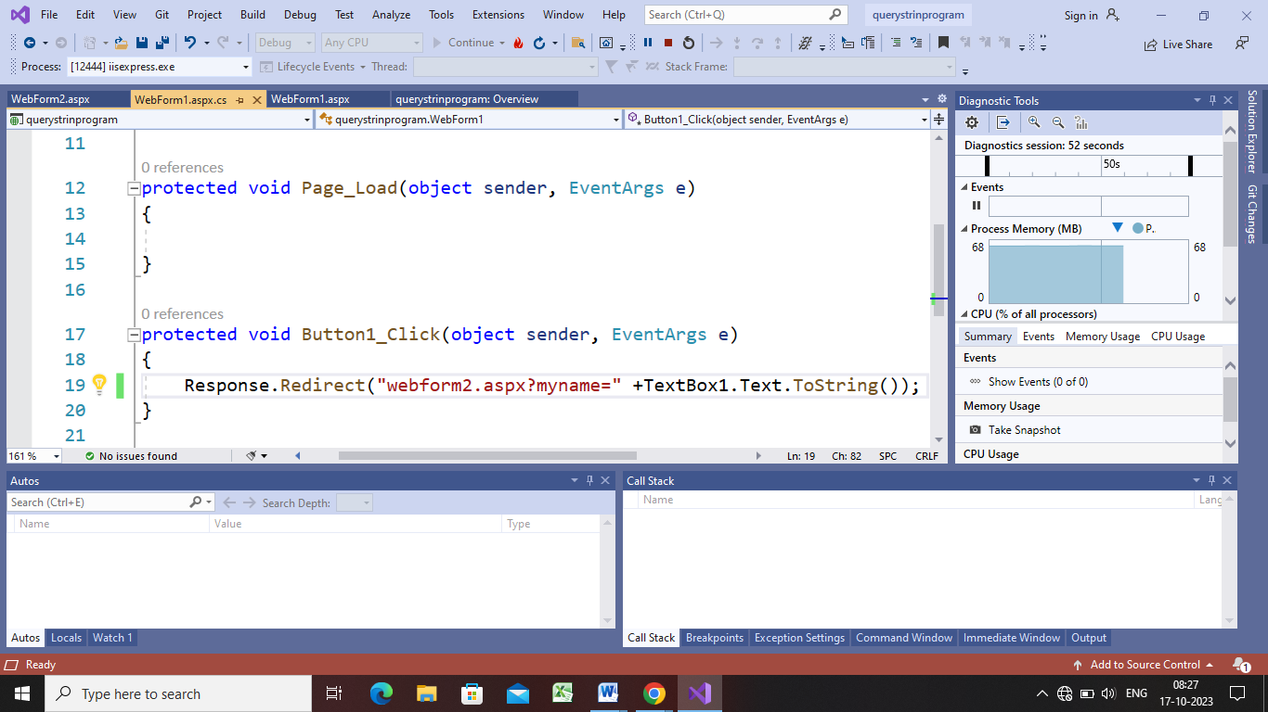

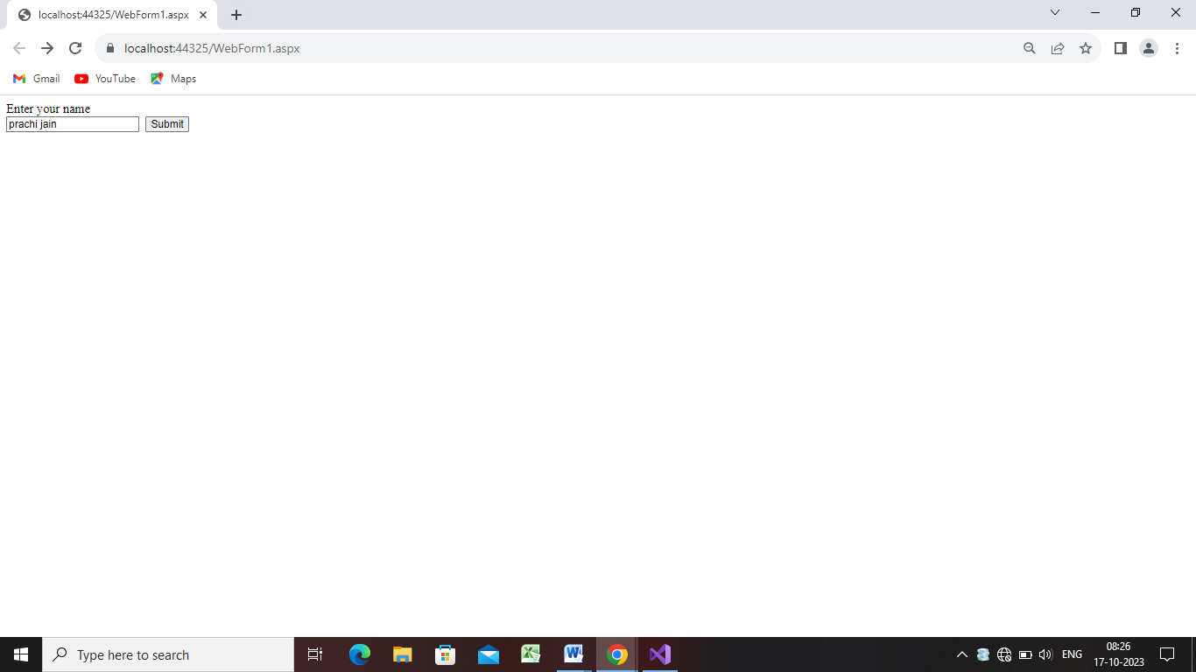

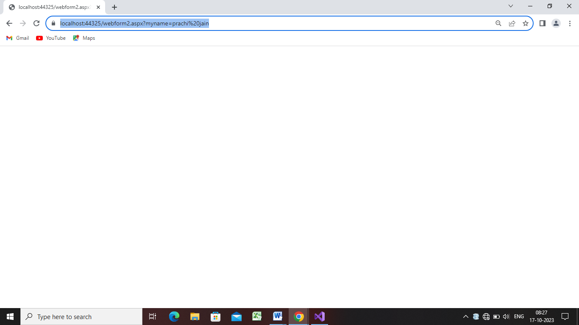

**Step5:**

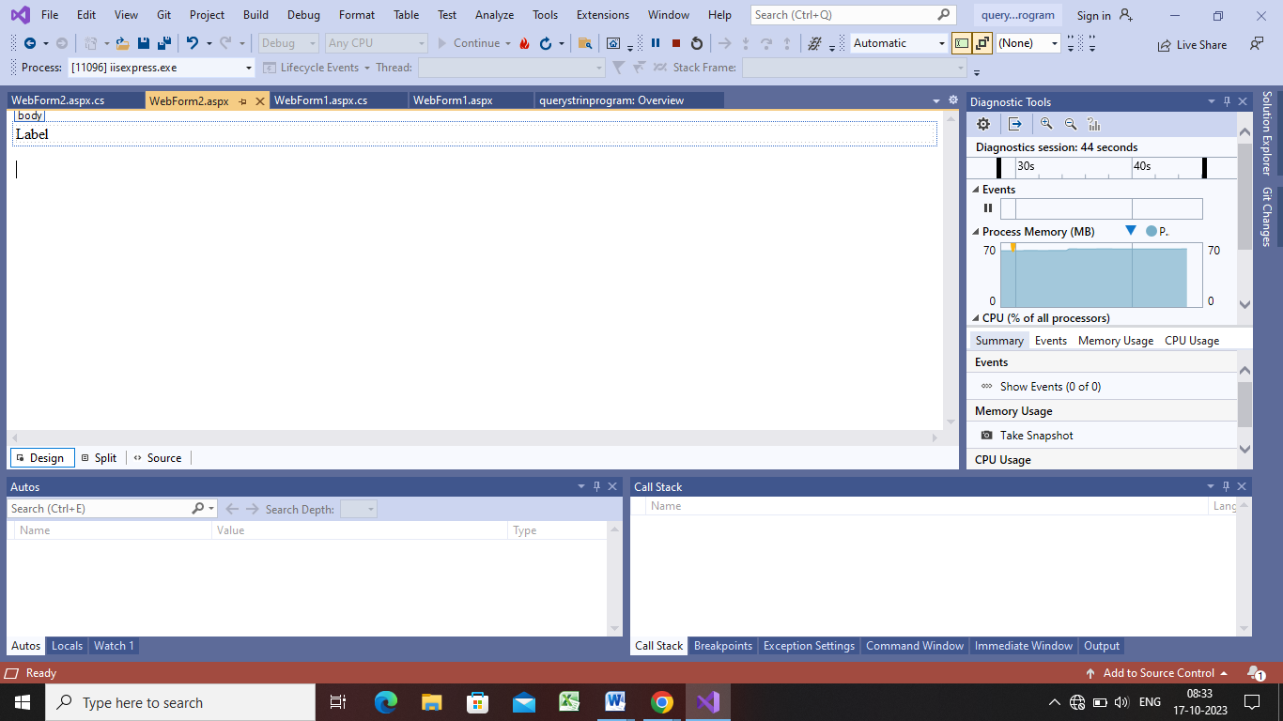

protected void Page_Load(object sender, EventArgs e)

{

Label1.Text = "welcome" + Request.QueryString["myname"];

}

